Football Predictor write-up plan

Intro
- Tired of bets not going your own way.
- I wanted to create a piece of software that provided insights into the outcome of matches.
- Football like all sports are vastly unpredictable and this is partly the reason why it captures the attention of so many.
- However, there are metrics which will shift the probability of an outcome to be pure chance to becoming probable.
- All fans of sport will do this subconsciously, if a team has been performing poorly recently and they are up against a team that are unbeaten in their past 10 games the prior subjective probability will no longer be pure chance.
- These fans and pundits share their subjective probability through their knowledge of past match results.
- The goal of this project is to use the powerful capabilities of machines and machine learning algorithms to look at past football matches, extract useful features and try to model a subjective probability of the match outcome, just as a sport fan or pundit would, but hopefully, better.

Work achieved so far

So far with the data I managed to collect, and the current linear regression machine learning model used I have achieved an average accuracy of 54% (predicts the outcome of a match correctly 54% of the time). To determine how good this score is, it must be compared to other simpler ‘models’. I must re-iterate here that when I refer to a ‘model’ I am simply referring to the method used to predict the matches. Examples of simpler models would be predicting that the home team win every match, this is simpler than my model as it uses no metrics about either team, it simply will always predict that the home team will win. This simple model achieved a 44% accuracy, (INSERT MODEL THAT SOLELY LOOKS AT RECENT FORM)

Machine vs Human

Reading this you may be asking the question whether a machine is inherently better at predicting matches than humans. My answer so far is that I am not sure. Obviously, the more data you provide the machine the better it will perform, and on statistical metrics a machine will outperform a human. However, it is worth highlighting the inherent human nature of sport, it is played by humans who do not operate solely on statistics, there are also natural human factors at play. The question is, as humans do we understand these better than machines? This is another objective of this project, understanding how best we can quantify human emotions like confidence and motivation.

Approach

Following this philosophical sidetrack let’s get back down to the stats. I started working on the football predictor backwards, starting from the end result. To identify what data would be the most beneficial to gather I needed to look at the end result and identify what factors affect the outcome of a football match, I came up with this list:

- Home/Away advantage
- Recent team form (Including more advanced statistics like passing accuracy, possession, shot accuracy and more)
- Individual player form
- Squad strength (injuries/suspensions)
- Team fatigue
- Bench strength
- H2H stats against this club
- Match importance
- Player fatigue levels

These stood out to me as the biggest statistical factors that I could easily retrieve and provide my machine learning model to learn from.

With this data in hand, I was ready to use it to train a machine learning model. The way I modelled each match in my training data was to display the data as follows:
Home stats,Away Stats,Home goals, Away goals

This would hopefully capture the difference between playing at home vs away as well as the other factors I mentioned previously.

Model Evaluation

To show that the home/away relationship is being picked up let’s look at a match between Arsenal & Manchester United
When Arsenal is at home the predicted outcome probabilities are:

Home Win: 76.21%
Draw: 8.30%
Away Win: 15.49%
if Arsenal were to play Man Utd away from home with the same recent stats the outcome probabilities are:

Home Win: 15.53%
Draw: 21.38%
Away Win: 63.09%

Indicating a higher chance for a draw but the overall prediction remains the same (Arsenal Win)
This proves that the model is picking up on some home advantage trends.

As I mentioned earlier the model is performing pretty well (53% accuracy) it is picking up on some important factors however it could be improved. Let’s compare the 54% accuracy to some baseline models:

Always predicting Home Win: Accuracy = 44%
Only using basic recent form stats:
Sports enthusiasts predictions on my data = 40%

Next steps

Upon implementing the first version of the predictor I noticed that I had missed out some key factors:

- Formation
- Manager
- Weather and pitch conditions
- Stage of the season – Start time compared to start and end of usual season…
- Momentum/Recent form trend – DONE
- Referee impact – DONE
- ELO score – DONE
Also, to further improve the current model, it should evaluate not just a team’s recent form generally, but some average of their recent performances considering their opponent. A team with amazing recent form against weak opponents differs to that of the same form against strong opponents. Something to consider (Keep a team strength variable based on their matches across various opponents) DONE
Evaluation of the results
With the addition of the ELO score feature. I have the following results using logistic regression:
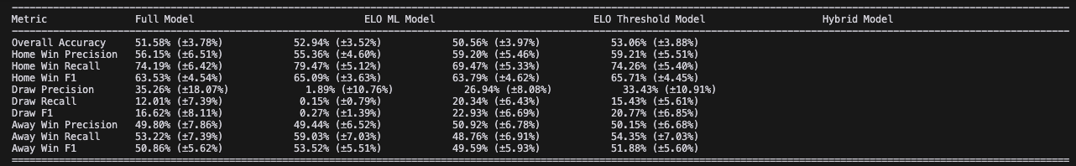

Subjective probability, why?

